Lab 9 - CSS Text

Instructions
- Answer the below question in the boxes if needed.
- For coding exercises, code on your computer and zip all your code before submission.
- Please submit the assignment after you finish.
- NO INLINE CSS CAN BE USED FOR THIS LAB

Part 1: Alignment
Steps:

- Go to VS Code and open the folder that we created in Lab 1
- Create a new HTML file inside the folder name "text.html". You can use the HTML skeleton we included in Chapter 1.
- Build HTML elements inside the body to replicate the screenshot below.
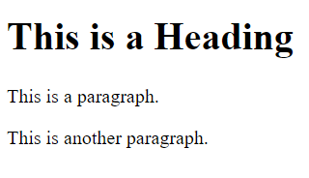
- Center align the Heading element

Part 2: Decoration

- Add a link below the third line of text in Part 1. It is a link element that redirects to Google (<a> tag). It should look like the one below.
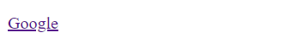
- Remove the underline from the hyperlink by using CSS.

Part 3: Text Fonts/Size/Weight

- Set the font of heading to “Verdana”, and font of other parts to “Courier New”.
- Set paragraph style to italics and increase their font size.
- Set the header font to normal instead of bold.
- Zip the HTML and CSS file and submit

